
Evaluating Cognitive Analytics in Aircraft Maintenance

A Case Study on Honeywell Aerospace

Marketing Analytics

Project Report submitted in partial fulfilment of the requirements for the award of the degree of

Bachelor of Business Administration
Specialised in Business Analytics

Under The Supervision of
Dr. Palak Gupta

Submitted By: Section -15

(Semester- 6)

Kushagra Tamang

MAY,2026

Acknowledgement

I would like to express my sincere gratitude to our faculty guide, Dr Palak Gupta, for her valuable guidance, continuous support, and encouragement throughout the completion of this project on “Evaluating the Cognitive Analytics Frontier.” Her insights and suggestions greatly helped in improving the quality of this report.

We would also like to thank our college and the Department of Business Administration for providing us with the opportunity to work on this project and enhance our understanding of Marketing Analytics and Customer Analytics concepts.

Finally, I would like to thank my team members for their cooperation, dedication, and contribution during the preparation of this report and presentation.

Executive Summary

This report analyses the case study “Evaluating the Cognitive Analytics Frontier” from a marketing analytics perspective, focusing on the operational and customer-related challenges faced by Honeywell Aerospace. The company aims to improve aircraft maintenance efficiency, reduce downtime, and enhance customer satisfaction through the use of cognitive analytics and predictive technologies.

The report examines key business issues such as delayed fault diagnosis, fragmented maintenance systems, aircraft downtime, and inefficient troubleshooting processes that negatively affect customer experience and increase customer churn risk. To address these challenges, marketing analytics concepts, including Customer Churn Analysis, Customer Lifetime Value (CLV), RFM Analysis, Market Basket Analysis, Predictive Analytics, and Customer Experience Metrics, have been applied.

The analysis highlights the importance of predictive maintenance, AI-driven support systems, and customer-centric maintenance strategies in improving operational efficiency and strengthening long-term customer relationships. The report also provides strategic recommendations such as implementing predictive analytics systems, developing cloud-based maintenance platforms, improving customer retention programs, and continuously monitoring customer experience KPIs.

Overall, the report concludes that integrating cognitive analytics and marketing analytics can help Honeywell Aerospace build a more proactive, efficient, and customer-focused maintenance ecosystem, leading to improved customer satisfaction, reduced operational costs, and long-term competitive advantage.

TABLE OF CONTENTS

S.no. | CHAPTERS
 | Introductions
 | Objectives of The Study
 | Company Overview
 | Problem Identification
Marketing Analytics Concepts & Analytical Framework
5.1. Customer Churn Analysis
 | 5.2. Customer Lifetime Value
 | 5.3. RFM Analysis
 | 5.4. Market Basket Analysis
 | 5.5. Predictive Analytics
 | 5.6. Customer Experience Metrics & KPI Framework
 | Strategic Recommendations
 | Limitation
13. | Conclusion

CHAPTER: 1
Introduction

In today’s competitive business environment, organisations are increasingly using marketing analytics, Artificial Intelligence (AI), and predictive technologies to improve operational efficiency, customer satisfaction, and business performance. Data-driven decision-making helps companies understand customer needs, enhance service quality, and build long-term customer relationships.

Honeywell Aerospace is a leading global provider of aerospace products, aircraft systems, and maintenance solutions. The company serves airlines, aircraft manufacturers, and defence organisations worldwide. However, the growing complexity of aircraft maintenance, delayed fault diagnosis, and fragmented maintenance information have created operational challenges that affect both efficiency and customer experience.

The case study “Evaluating the Cognitive Analytics Frontier” examines how Honeywell Aerospace can improve its maintenance support system using cognitive analytics and predictive technologies. The company aims to reduce aircraft downtime, improve maintenance accuracy, and provide faster and more effective support to its customers.

This report analyses the challenges Honeywell Aerospace faces from a marketing analytics perspective. It applies concepts such as customer churn analysis, Customer Lifetime Value (CLV), customer experience metrics, predictive analytics, and market basket analysis to evaluate customer-related issues and propose data-driven solutions. The report also provides strategic recommendations to improve customer satisfaction, customer retention, and overall operational performance by leveraging intelligent maintenance systems and advanced analytics.

CHAPTER: 2
Objectives of the Study

The primary objective of this report is to analyse the business challenges faced by Honeywell Aerospace and evaluate how marketing analytics and cognitive analytics can improve customer satisfaction, maintenance efficiency, and customer retention.

The specific objectives of the study are:

- To identify the major operational and customer-related challenges faced by Honeywell Aerospace in aircraft maintenance and support services.

- To analyse the factors contributing to customer dissatisfaction and potential customer churn.

- To evaluate the role of cognitive analytics and predictive maintenance in improving maintenance efficiency and reducing aircraft downtime.

- To apply marketing analytics concepts such as Customer Lifetime Value (CLV), customer churn analysis, RFM analysis, and market basket analysis to understand customer behaviour and business impact.

- To design customer experience metrics and Key Performance Indicators (KPIs) for monitoring service performance and customer satisfaction.

- To provide strategic recommendations for improving customer retention, operational efficiency, and long-term business performance through data-driven solutions.

CHAPTER: 3
Company Overview

Honeywell Aerospace is one of the world’s leading aerospace technology and manufacturing companies, headquartered in Phoenix, Arizona. The company is a major division of Honeywell International and provides a wide range of aerospace products, software solutions, and maintenance services to customers across the global aviation industry. Its customers include airlines, aircraft manufacturers, airports, defence organisations, and space contractors.

Honeywell Aerospace offers various products and services such as aircraft engines, navigation systems, cockpit displays, communication systems, radar and surveillance systems, maintenance solutions, and repair support services. The company is known for its advanced onboard maintenance systems that help monitor aircraft performance and detect technical issues during flight operations.

As the aviation industry becomes more data-driven and technologically advanced, Honeywell Aerospace has focused on improving maintenance efficiency and customer support through cognitive analytics, Artificial Intelligence (AI), and predictive maintenance technologies. The company aims to provide faster fault diagnosis, reduce aircraft downtime, and improve operational reliability for its customers. However, the increasing complexity of aircraft systems and fragmented maintenance information has created challenges in troubleshooting and maintenance operations.

To address these challenges, Honeywell Aerospace is exploring intelligent maintenance systems and cloud-based analytical platforms that can enhance decision-making, improve customer experience, and support long-term customer retention. The company’s focus on innovation and data-driven solutions highlights the growing importance of marketing analytics and customer analytics in the aerospace industry.

CHAPTER: 4
Problem Identification

Honeywell Aerospace is facing significant challenges in managing aircraft maintenance and support operations efficiently. Due to the increasing complexity of aircraft systems and the large volume of maintenance data, technicians often struggle to diagnose faults quickly and accurately. The existing maintenance process relies heavily on multiple manuals, disconnected databases, and manual troubleshooting methods, which increases the time required to identify and resolve technical issues.

One of the major problems highlighted in the case study is aircraft downtime. When an aircraft is grounded because of technical issues, airlines may face financial losses, operational delays, and customer dissatisfaction. Since technicians work under high time pressure, they often use a process known as “shotgun maintenance,” where multiple parts are replaced without accurately identifying the root cause of the problem. This leads to unnecessary replacement costs and inefficient maintenance practices.

Another important issue is fragmented information management. Maintenance-related information, such as fault isolation manuals, repair documents, service bulletins, and maintenance history, is stored across different systems, making it difficult for technicians to access relevant information quickly. As a result, troubleshooting becomes slower and less effective, negatively impacting service quality and operational performance.

From a marketing analytics perspective, these operational inefficiencies can directly affect customer satisfaction, customer loyalty, and long-term customer retention. Airlines and aviation operators expect fast, accurate, and reliable maintenance support to minimise downtime and maintain operational efficiency. Delayed repairs and poor service experiences may reduce customer trust and increase the risk of customer churn.

Therefore, Honeywell Aerospace needs a smarter and more integrated maintenance support system that uses cognitive analytics, predictive maintenance, and AI-driven solutions to improve maintenance accuracy, reduce downtime, enhance customer experience, and strengthen long-term customer relationships.

CHAPTER: 5
Marketing Analytics Concepts and Analytical Framework

5.1. Customer Churn Analysis
Customer churn refers to the loss of customers due to dissatisfaction, poor service quality, or better alternatives in the market. In the case of Honeywell Aerospace, issues such as delayed fault diagnosis, aircraft downtime, inaccurate maintenance, and fragmented support systems can negatively impact customer satisfaction and increase churn risk.
Airlines depend on fast and reliable maintenance services to avoid operational delays and financial losses. Poor troubleshooting and delayed repairs may reduce customer trust and encourage customers to switch to competitors offering more efficient maintenance solutions.

Major Factors Contributing to Customer Churn
Factors | Impact on Customers
Aircraft Downtime | Financial losses and operational delays
Delayed Fault Diagnosis | Reduced maintenance efficiency
Inaccurate Troubleshooting | Increased repair costs
Poor Support Systems | Lower customer satisfaction
Poor Support Systems | Slow decision-making process

Interpretation
The analysis indicates that aircraft downtime and delayed maintenance support are major contributors to customer dissatisfaction. Improving maintenance accuracy and reducing response time can help Honeywell Aerospace strengthen customer relationships and improve customer retention.

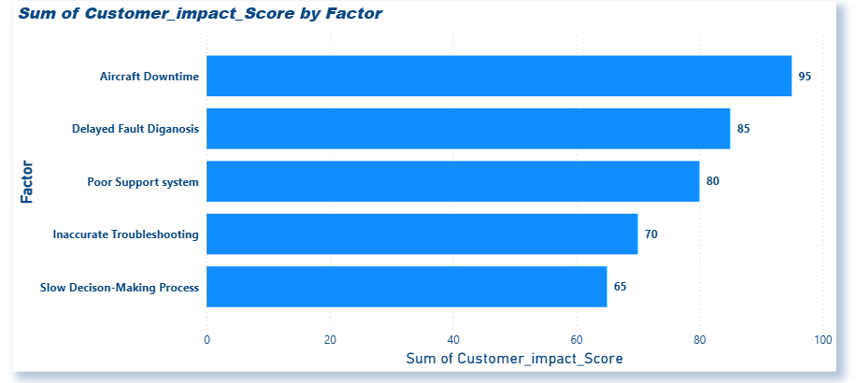

5.2. Customer Lifetime Value (CLV)
Customer Lifetime Value (CLV) refers to the total revenue a customer generates throughout their relationship with a company. In the aerospace industry, airline operators are considered high-value customers due to long-term maintenance contracts and continuous service partnerships.
For Honeywell Aerospace, improving maintenance efficiency and customer support can enhance customer satisfaction, increase contract renewals, and strengthen long-term customer loyalty, ultimately improving overall profitability.

Customer Lifetime Value Formula
CLV = (Average\ Annual\ Revenue\times Customer\ Lifespan) -
Customer\ Acquisition\ Cost

Sample CLV Calculation
Customer | Annual Revenue | Customer Lifespan | CLV
Airline A | $5 Million | 10 Years | $48 Million
Airline B | $7 Million | 8 Years | $53 Million
Airline C | $4 Million | 12 Years | $47 Million

Interpretation
The analysis shows that airline customers contribute substantial long-term value to Honeywell Aerospace. Losing even a single major customer may result in significant financial loss for the company. Therefore, improving customer retention through predictive maintenance, faster troubleshooting, and enhanced support services is essential for maximising Customer Lifetime Value.

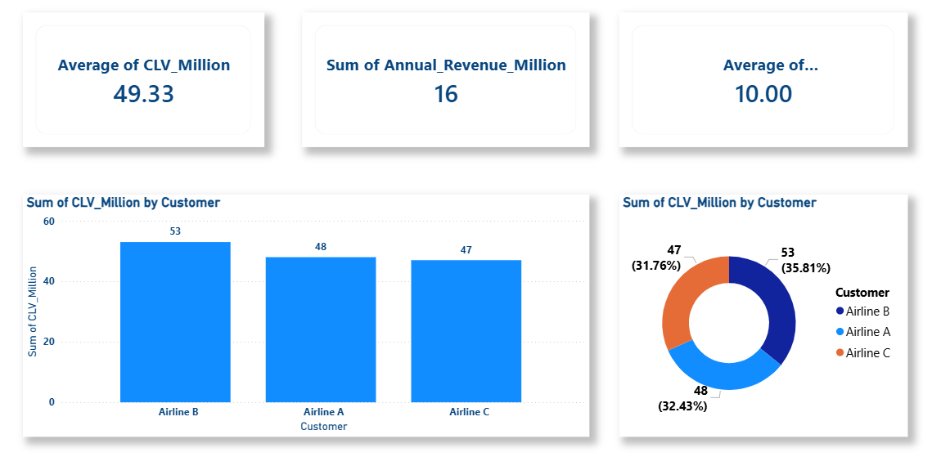
5.3. RFM Analysis
RFM Analysis is a customer analytics technique used to identify valuable customers based on Recency, Frequency, and Monetary Value. It helps organisations understand customer importance and improve retention strategies.
For Honeywell Aerospace, RFM Analysis helps identify high-value airline customers, frequent service users, and customers generating high revenue through maintenance and support services.
.
Components of RFM Analysis
Component | Meaning | Business Importance
Recency | How recently the customer used the service | Helps identify active customers
Frequency | How often does the customer purchase services | Indicates customer engagement
Monetary Value | How much revenue the customer generates | Identifies high-value customers

Sample RFM Analysis Table
Customer | Recency Score | Frequency Score | Monetary Score | Customer Category
Airline A | 5 | 5 | 5 | High-Value Customer
Airline B | 4 | 3 | 4 | Loyal Customer
Airline C | 2 | 2 | 3 | At-Risk Customer
Airline D | 1 | 1 | 2 | Low Engagement

Interpretation
The RFM analysis indicates that some customers contribute significantly higher value and engagement compared to others. High-value customers should receive premium support services, personalised maintenance solutions, and faster response systems to improve customer satisfaction and retention. Customers with lower engagement levels may require targeted retention strategies and improved service experiences.

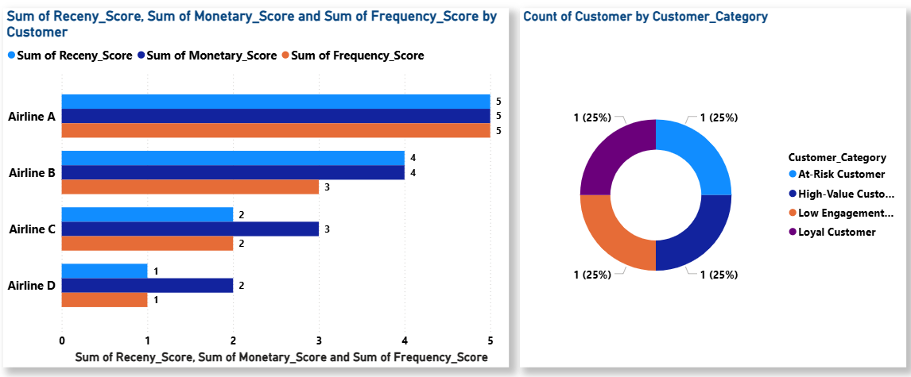5.4. Market Basket Analysis
Market Basket Analysis is a customer analytics technique used to identify products or services that are frequently purchased together. This analysis helps organisations understand customer purchasing patterns and identify opportunities for cross-selling, upselling, and bundled service offerings.
In the case of Honeywell Aerospace, customers using advanced maintenance services may also require additional support solutions such as spare part contracts, technician training, cloud-based monitoring systems, and AI-powered diagnostic tools. Understanding these relationships can help the company create integrated service packages and improve customer value.

Sample Market Basket Analysis Table
Primary Service | Frequently Associated Service | Business Opportunity
Predictive Maintenance | Spare Parts Contract | Cross-selling
AI Diagnostics | Technician Training | Service Bundling
Cloud Monitoring | Maintenance Support Plans | Customer Retention
Aircraft Repair Services | Real-Time Analytics Tools | Upselling

Interpretation
The analysis shows that customers purchasing one maintenance-related service are likely to purchase additional support services that improve operational efficiency. By combining related services into bundled offerings, Honeywell Aerospace can increase customer convenience, strengthen customer relationships, and improve overall revenue generation.

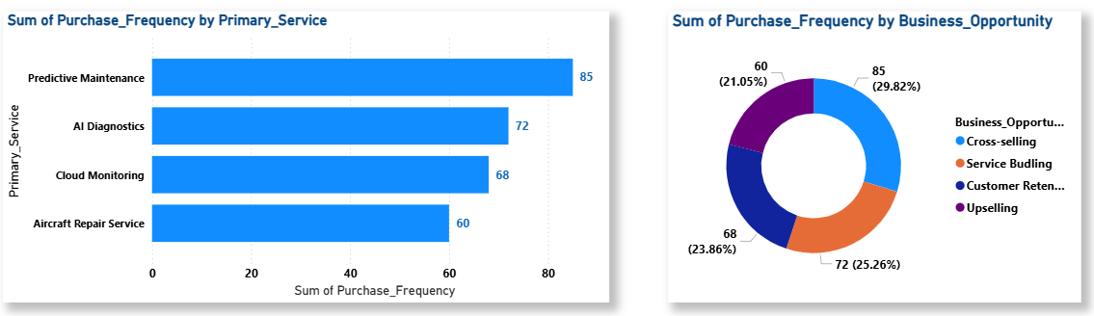

5.5. Predictive Analytics
Predictive Analytics uses historical data, Artificial Intelligence (AI), machine learning, and real-time monitoring to predict operational issues before they occur. In the aerospace industry, it helps identify equipment failures early, reduce maintenance delays, and improve operational efficiency.
Honeywell Aerospace aims to use predictive maintenance systems to improve maintenance accuracy and provide faster technical support. By analysing sensor data, maintenance history, and fault codes, predictive systems can detect potential failures in advance, reducing aircraft downtime, operational costs, and improving customer satisfaction.

Predictive Analytics Process: Simple Workflow
Sensor Data → AI Analysis → Failure Prediction → Maintenance Action → Reduced Downtime

Benefits of Predictive Analytics
Benefits | Business Impact
Early Fault Detection | Prevents major failures
Reduced Aircraft Downtime | Improves operational efficiency
Faster Troubleshooting | Enhances customer experience
Lower Maintenance Costs | Reduces unnecessary repairs
Improved Service Reliability | Strengthens customer loyalty

Interpretation
The implementation of predictive analytics can significantly improve maintenance efficiency and customer experience. By identifying technical issues before they become critical, Honeywell Aerospace can provide proactive support services and minimise operational disruptions for airline customers.

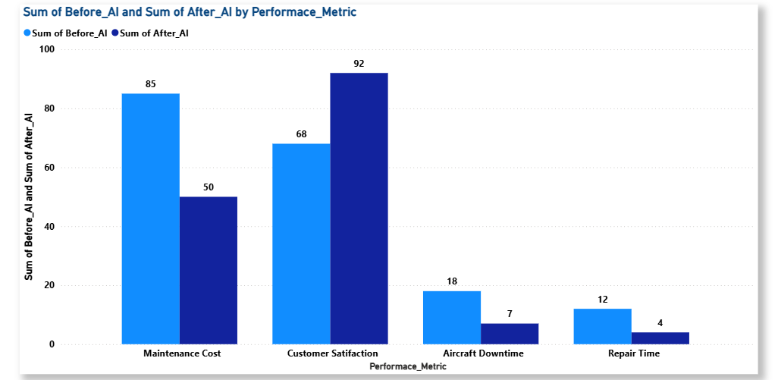

5.6. Customer Experience Metrics and KPI Framework
Customer Experience Metrics are performance indicators used to measure customer satisfaction, service quality, operational efficiency, and overall customer engagement. In the aerospace industry, efficient maintenance support and quick problem resolution are essential for maintaining strong customer relationships and long-term contracts.
For Honeywell Aerospace, monitoring customer-related Key Performance Indicators (KPIs) can help evaluate maintenance performance, identify operational weaknesses, and improve customer retention strategies. These metrics also support data-driven decision-making and continuous service improvement.

Key Customer Experience Metrics
KPI | Purpose | Business Importance
Customer Satisfaction Score (CSAT) | Measures customer satisfaction level | Improves service quality
Net Promoter Score | Measures customer loyalty | Indicates brand trust
Average Resolution Time | Measures maintenance response speed | Reduces operational delays
First-Time Fix Rate | Measures troubleshooting accuracy | Improves maintenance efficiency
Downtime Reduction Percentage | Measures operational improvement | Enhances customer experience
Repeat Contract Rate | Measures customer retention | Indicates long-term loyalty

Sample KPI Dashboard Table
KPI | Current Performance | Target Performance
Customer Satisfaction Score | 72% | 90%
Average Resolution Time | 12 Hours | 4 Hours
First-Time Fix Rate | 65% | 90%
Downtime Reduction | 20% | 50%
Repeat Contract Rate | 70% | 92%

Interpretation
The KPI framework highlights the importance of improving maintenance efficiency and customer support systems. Reducing response time, improving troubleshooting accuracy, and minimising aircraft downtime can significantly improve customer satisfaction and strengthen long-term customer relationships.

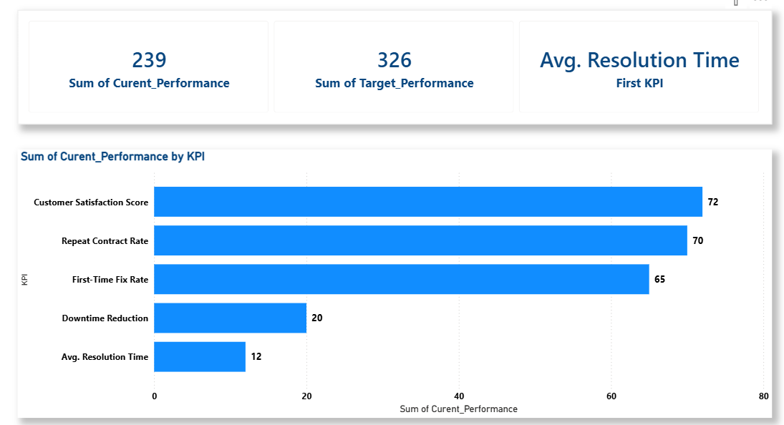

CHAPTER: 6
Strategic Recommendations
Based on the analysis of the case study, several strategic recommendations can be proposed to help Honeywell Aerospace improve maintenance efficiency, customer satisfaction, and long-term customer retention through the effective use of marketing analytics and cognitive technologies.

1. Implement AI-Powered Predictive Maintenance Systems
Honeywell Aerospace should adopt AI-driven predictive maintenance systems that can analyse aircraft sensor data, fault codes, and maintenance history to predict failures before they occur. Predictive maintenance can reduce aircraft downtime, improve troubleshooting accuracy, lower maintenance costs, and enhance customer satisfaction through proactive maintenance support.

Benefits
- Reduced operational delays
- Faster fault detection
- Improved maintenance efficiency
- Better customer experience

2. Develop a Cloud-Based Maintenance Support Platform
The company should create a centralised cloud-based maintenance platform that allows technicians to access maintenance manuals, troubleshooting data, service bulletins, and real-time analytics from any location. This can reduce information fragmentation and improve decision-making speed during maintenance operations.

Benefits
- Real-time information access
- Faster troubleshooting process
- Improved technician productivity
- Better global maintenance coordination

3. Strengthen Customer Retention and Loyalty Programs
Honeywell Aerospace should introduce customer-focused retention strategies such as premium maintenance contracts, priority technical support, personalised service plans, and long-term partnership programs for high-value customers. These initiatives can improve customer loyalty and increase Customer Lifetime Value (CLV).

Benefits
- Improved customer retention
- Increased repeat contracts
- Stronger customer relationships

4. Build a Technician Knowledge-Sharing Platform
The company should develop a collaborative knowledge-sharing system where technicians can share troubleshooting experiences, repair solutions, and maintenance best practices. This crowdsourced approach can improve problem-solving efficiency and reduce maintenance errors.

Benefits
- Faster issue resolution
- Improved troubleshooting accuracy
- Enhanced learning and collaboration
- Continuous improvement of maintenance knowledge

5. Use Customer Experience KPIs for Continuous Monitoring
Honeywell Aerospace should continuously monitor customer-related KPIs such as Customer Satisfaction Score (CSAT), Net Promoter Score (NPS), downtime reduction, response time, and First-Time Fix Rate. Regular performance monitoring will help identify operational gaps and improve customer service quality.

Benefits
- Data-driven decision-making
- Improved service quality
- Better operational control
- Enhanced customer satisfaction

6. Expand Cross-Selling and Bundled Service Offerings
Based on Market Basket Analysis, Honeywell Aerospace should offer bundled maintenance packages that combine predictive maintenance, cloud monitoring, spare parts contracts, and technician training services. Integrated service offerings can improve customer convenience and increase revenue opportunities.

Benefits
- Increased cross-selling opportunities
- Higher customer value
- Improved customer engagement
- Additional revenue generation

CHAPTER: 7
Limitations of the Study

This report is based primarily on the case study “Evaluating the Cognitive Analytics Frontier” and uses conceptual analysis to evaluate the role of marketing analytics and predictive maintenance in the aerospace industry. The study has certain limitations that should be considered.

- The report uses synthetic and hypothetical datasets created for analytical and visualisation purposes, as real-time operational data from Honeywell Aerospace was not publicly available.

- The analysis is limited to the information provided in the case study and does not include real-world financial or customer performance data.

- The project focuses mainly on marketing analytics and customer analytics perspectives rather than the technical implementation of Artificial Intelligence and machine learning systems.

- Time constraints and limited access to industry-specific operational data may have restricted deeper quantitative analysis.

- The findings and recommendations are conceptual in nature and may vary based on actual business conditions and technological implementation.

CHAPTER: 8
Conclusion

The case study “Evaluating the Cognitive Analytics Frontier” highlights the growing importance of marketing analytics, cognitive analytics, and predictive technologies in improving operational efficiency and customer experience within the aerospace industry. Honeywell Aerospace faces significant challenges related to delayed fault diagnosis, fragmented maintenance systems, aircraft downtime, and inefficient troubleshooting processes, all of which directly impact customer satisfaction and long-term customer retention.

The analysis conducted in this report demonstrates that customer analytics concepts such as Customer Lifetime Value (CLV), customer churn analysis, RFM analysis, market basket analysis, and customer experience metrics can help the company better understand customer behaviour and improve service quality. In addition, the implementation of predictive analytics and AI-powered maintenance systems can significantly reduce downtime, improve maintenance accuracy, and enhance operational performance.

The findings also indicate that high-value airline customers require fast, reliable, and personalised maintenance support services. Therefore, adopting cloud-based maintenance platforms, predictive maintenance systems, and customer-centric retention strategies can strengthen customer relationships and improve long-term business profitability.

Overall, the integration of cognitive analytics and marketing analytics can help Honeywell Aerospace transition from a reactive maintenance approach to a proactive and intelligent maintenance ecosystem. By focusing on customer satisfaction, operational efficiency, and data-driven decision-making, the company can achieve sustainable competitive advantage and deliver greater value to its customers in the evolving aerospace industry.

